**Experiment 36**

**AIM :**

To design turing machine(TM) of palindrome **ababa c** in automata.

**Design and output:**

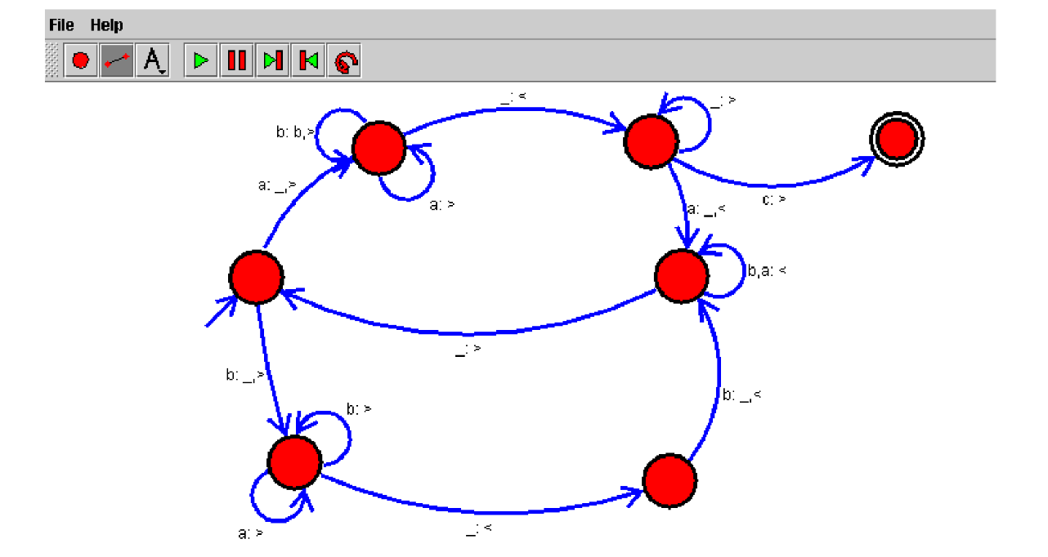

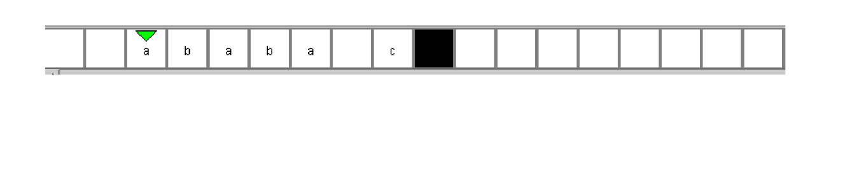

**Result:** Thus designing TM of palindrome **ababa c** is done and verified by giving sample inputs.